**UNIVERSITY OF MUMBAI**

A PROJECT REPORT ON

**SOCIAL NETWORKING SITE**

SUBMITTED BY

**Mr. Sourabh. S. Khaire**

Under the guidance of

**Prof. NITESH KUMAR**

**Master of Computer Applications (M.C.A.)**

Late Shri Vishnu Waman Charitable Trust’s

**VIVA SCHOOL OF M.C.A.**

**Shirgaon, Virar (East)**

**2018 – 19**



**CERTIFICATE**

This is to certify that

**Mr. Sourabh. S. Khaire**

Have satisfactorily completed the project entitled

(**SOCAIL NETWORKING SITE**)

Towards the partial fulfillment of the

MASTER OF COMPUTER APPLICATIONS (M.C.A.)

As laid by University of Mumbai.

**________________ ______________________ __________________**

**Principal External Examiner Internal Guide**

**Acknowledgement**

2

**We are extremely grateful and remain indebted to our guide Prof. NITESH KUMAR** **for being a source of inspiration and for their constant support in the Design, Implementation and Evaluation of the project.**

**We are thankful to him for his constant constructive criticism and invaluable suggestions, which benefited us a lot while developing the MINI project on “SOCIAL NETWORKING SITE”.**

**He has been a constant source of inspiration and motivation of our hard work. He has been very co-operative throughout this project work. It would be our pleasure to express our thanks for their encouragement, co-operation and without which we might not be able to accomplish this project.**

**We express our gratitude to Prof. NITESH KUMAR** **sir for providing the information to carry out the project and to all staff members who were directly and indirectly instrument in enabling us to stay committed for the project.**

**We are also grateful, to the principal Dr. MINESH ADE for encouraging us**

**INDEX**

|  |  |  |
| --- | --- | --- |
| **Sr. No** | **Contents** | **Page No.** |
| 1 | Introduction to the Project  Introduction  Scope  Operational Environment  Detailed Description of Technology Used |  |
| 2 | Proposed System  Introduction  Objective |  |
| 3 | Analysis & Design  Gantt Chart  Pert Chart  Test Cases |  |
| 4 | Hardware & Software Requirement Specifications |  |
| 5 | Project Workflow |  |
| 6 | Screenshots |  |
| 7 | Limitations |  |
| 8 | Future Enhancement |  |
| 9 | Conclusion |  |
| 10 | Bibliography |  |

**Introduction**

We define social network sites as web-based services that allow individuals to (1) construct a public or semi-public profile within a bounded system, (2) articulate a list of other users with whom they share a connection, and (3) view and traverse their list of connections and those made by others within the system.

While Social Networking Sites have implemented a wide variety of technical features, their backbone consists of visible profiles that display an articulated list of Friends one who are also users of the system. Each profile in Social Networking has unique ID.

After joining a Social Networking Sites, an individual is asked to fill out forms containing a series of questions. The profile is generated using the answers to these questions, which typically include descriptors such as age, location, interests, and an "about me" section. These sites also encourage users to upload a profile photo.

These sites allow users to enhance their profiles by adding multimedia content or modifying their profile's look and feel.

**Scope**

The social networking website is an online community designed to make social life more active and stimulating. The social network can help you maintain existing relationships with people and share pictures and messages, and establish new ones by reaching out to people you've never met before.

This website also provides the features of blogging all at one place. The main idea behind blogging is to share your thoughts with all your friends which can be read by all the users using the website. This blog can be handled by the user as he wants for example adding videos and photos also.

This website enhances Advertisements of products. People using this website can buy and sell products from this website. The main purpose behind this Advertisement functionality will help people to buy products in trusted circle.

**Operational Environment**

Operating environment is the environment in which users run application software. The environment consists of a user interface provided by an applications manager and usually an application programming interface (API) to the applications manager.

An operating environment is usually not a full operating system but is a form of middleware that rests between the OS and the application. For example, the first version of Microsoft Windows, Windows 1.0, was not a full operating system, but a GUI laid over DOS albeit with an API of its own. Similarly, the IBM U2 system operates on both Unix/Linux and Windows NT. Usually the user interface is text-based or graphical, rather than a command-line interface (e.g., DOS or the Unix shell), which is often the interface of the underlying operating system.

**Detailed Description of Technology Used**

1. **HTML**

Hypertext Markup Language (HTML) is the standard [markup language](https://en.wikipedia.org/wiki/Markup_language) for creating [web pages](https://en.wikipedia.org/wiki/Web_page) and [web applications](https://en.wikipedia.org/wiki/Web_application). With [Cascading Style Sheets](https://en.wikipedia.org/wiki/Cascading_Style_Sheets) (CSS) and [JavaScript](https://en.wikipedia.org/wiki/JavaScript), it forms a triad of cornerstone technologies for the [World Wide Web](https://en.wikipedia.org/wiki/World_Wide_Web).[[4]](https://en.wikipedia.org/wiki/HTML#cite_note-4) [Web browsers](https://en.wikipedia.org/wiki/Web_browser) receive HTML documents from a [web server](https://en.wikipedia.org/wiki/Web_server) or from local storage and render the documents into multimedia web pages. HTML describes the structure of a web page [semantically](https://en.wikipedia.org/wiki/Semantic_Web) and originally included cues for the appearance of the document.

1. **Java Script**

JavaScript is a very powerful client-side scripting language. JavaScript is used mainly for enhancing the interaction of a user with the webpage. In other words, you can make your webpage more lively and interactive, with the help of JavaScript. JavaScript is also being used widely in game development and [Mobile](https://www.guru99.com/mobile-testing.html) application development.

1. **Bootstrap**

Bootstrap is a [free and open-source](https://en.wikipedia.org/wiki/Free_and_open-source_software) front-end library for designing [websites](https://en.wikipedia.org/wiki/Website) and [web applications](https://en.wikipedia.org/wiki/Web_application). It contains [HTML](https://en.wikipedia.org/wiki/HTML)- and [CSS](https://en.wikipedia.org/wiki/CSS)-based design templates for [typography](https://en.wikipedia.org/wiki/Typography), forms, buttons, navigation and other interface components, as well as optional [JavaScript](https://en.wikipedia.org/wiki/JavaScript) extensions. Unlike many web frameworks, it concerns itself with [front-end development](https://en.wikipedia.org/wiki/Front-end_web_development) only.

1. **PHP**

Hypertext Preprocessor (or simply PHP) is a [server-side scripting](https://en.wikipedia.org/wiki/Server-side_scripting) language designed for [web development](https://en.wikipedia.org/wiki/Web_development) but also used as a [general-purpose programming language](https://en.wikipedia.org/wiki/General-purpose_programming_language).

PHP code may be embedded into [HTML](https://en.wikipedia.org/wiki/HTML) code, or it can be used in combination with various [web template systems](https://en.wikipedia.org/wiki/Web_template_system), web content management systems, and [web frameworks](https://en.wikipedia.org/wiki/Web_framework). PHP code is usually processed by a PHP [interpreter](https://en.wikipedia.org/wiki/Interpreter_(computing)) implemented as a [module](https://en.wikipedia.org/wiki/Plugin_(computing)) in the web server or as a [Common Gateway Interface](https://en.wikipedia.org/wiki/Common_Gateway_Interface) (CGI) executable. The web server combines the results of the interpreted and executed PHP code, which may be any type of data, including images, with the generated web page. PHP code may also be executed with a [command-line interface](https://en.wikipedia.org/wiki/Command-line_interface) (CLI) and can be used to implement [standalone](https://en.wikipedia.org/wiki/Computer_software) [graphical applications](https://en.wikipedia.org/wiki/Graphical_user_interface)

1. **MySQL**

MySQL is a fast, easy-to-use RDBMS being used for many small and big businesses. MySQL is developed, marketed and supported by MySQL AB, which is a Swedish company. MySQL is becoming so popular because of many good reasons −

* MySQL is released under an open-source license. So you have nothing to pay to use it.
* MySQL is a very powerful program in its own right. It handles a large subset of the functionality of the most expensive and powerful database packages.
* MySQL uses a standard form of the well-known SQL data language.
* MySQL works on many operating systems and with many languages including PHP, PERL, C, C++, JAVA, etc.
* MySQL works very quickly and works well even with large data sets.

MySQL is very friendly to PHP, the most appreciated language for web development.

1. **Wamp Server:**

WampServer is a Windows web development environment. It allows you to create web applications with Apache2, PHP and a MySQL database. It also comes with PHPMyAdmin and SQLiteManager to easily manage your databases. WampServer installs automatically (installer), and its usage is very intuitive.

Stands for "Windows, Apache, MySQL, and PHP." WAMP is a variation of LAMP for Windows systems and is often installed as a software bundle (Apache, MySQL, and PHP). It is often used for web development and internal testing, but may also be used to serve live websites.

**Proposed System**

Product intends to provide a well-established social networking system. This documents a networking system scope, functionalities, requirements and feasibility. This project aims to develop a website which provides a Communication among peoples on network, which works quite similar to Social Networking Site like Facebook, Orkut etc.

Social networking sites allow users to communicate with people, share ideas, activities, events, and interests within their individual networks. Social network sites such as MySpace, Facebook, Orkut, and Google+ have attracted millions of users, many of whom have integrated these sites into their daily practices. There are hundreds of Social Networking Sites, with various technological affordances, supporting a wide range of interests and practices. Sites also vary in the extent to which they incorporate new information and communication tools, such as mobile connectivity, blogging, and photo/video-sharing.

**Objective**

The objective of the project is to explain and elaborate the concept of “Social Networking Sites” to the users, hence providing a reliable and efficient Communication online so as to assist users to afford it without much trouble.

This project “SOCIAL NETWORKING SYSTEM” is divided into following modules.

1. System

* Creating a public profile having social, professional and personal information
* Easily password recovery processing
* Add friends to your friend box accept request

1. Users

* Creating a public profile having social, professional and personal information
* Send Friend Request to other users to make friends
* Search People easily on entire network
* Ease of editing of profile anytime
* Upload and Share Images on network

1. Chats

* Chat with Online friends
* Send messages to other friends
* Reply directly to incoming user messages

1. Group

* This module maintaining the groups i.e. admin and groups members.

**Analysis & Design**

**Gantt Chart:**

It is also known as bar chart and it is used exclusively for scheduling purpose. It is a project controlling technique. Budgeting and resource planning. A Gantt is a bar chart with each bar representing activity. The bars are drawn against a time line. The length of time planned for the activity. The Gantt chart in the figure shows the blue part is slack time that is the latest by which a task has been finished.

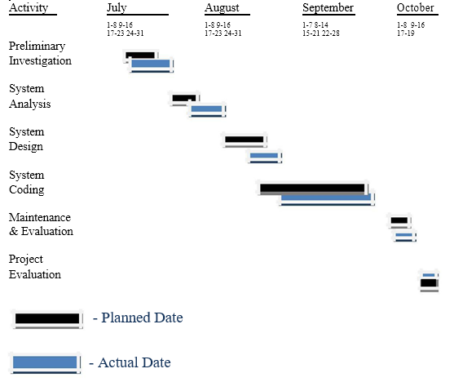

**Pert Chart:**

Pert chart is organized for events, activities or tasks. It is a scheduling device that shows graphically the order of the tasks to be performed. It enables the calculation of the critical path. The time and cost associated along a path is calculated and the path requires the greatest amount of elapsed time in critical path.

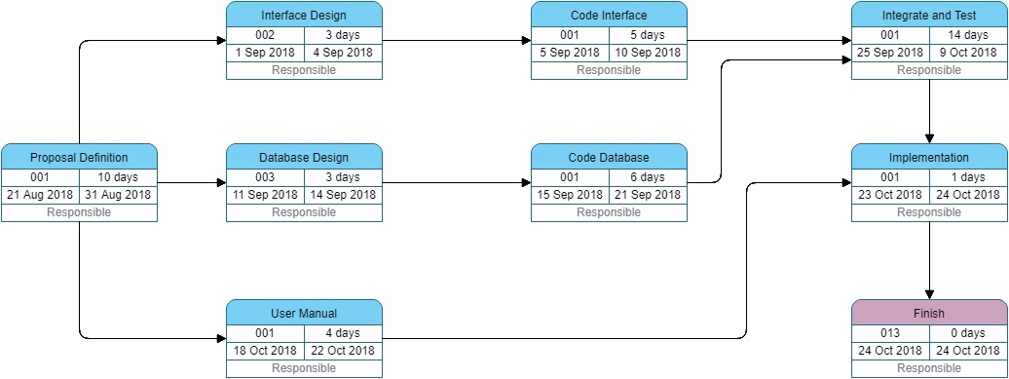

**TEST CASES**

|  |  |  |  |  |  |  |  |  |
| --- | --- | --- | --- | --- | --- | --- | --- | --- |
| Testcase id | Test case name | Test case desc | Test steps | | | Test case status | Test status (p/f) | Test prority |
| step | expected | actual |
| Login | Check Login | To check login name and password match the user description or not | Enter wrong user name and password and click on login | Error message “Invalid Username or Password” |  | Login | Fail | High |
|  | Check login | To check the error when user name and password kept empty | Click on login without entering user name and password | Error message “Please enter user name and password.” |  | Login | Fail | High |
|  |  |  | Enter user name and password and then click login | Pass on main home page. |  | Login | Pass | High |
| Change Password | Check Change Password | To check the error when old password field is empty | Enter New Password Without entering old Password and Click on Change | Error Message “Please Enter Old Password” |  | Change Password | Fail | High |
|  |  | To check the error when new Password Field is empty | Entre All passwords Excepts New Password and click on change | Error message ”Please Enter New Password” |  | Change Password | Fail | High |
|  |  | To Check the Error when New And Retype new Password Did not matched | Enter Wrong Password in retype password field | Error Message “Password Did not Matched” |  | Change Password | Fail | High |
|  |  |  | Enter All Password Correctly and Click on change | Password Changed Successfully |  | Change Password | Pass | High |
| Mobile | Check Mobile | To Check error when user enters Invalid mobile number | Enter Number less then 10 Length | Error Message “Invalid Mobile Number” |  | Register | Fail | High |
|  |  |  | Enter Characters in number fields | Error Message “Invalid Mobile Number” |  | Register | Fail | High |
| Fields | Check Fields | To check error whether it takes null values or not | Click On Register Without entering Values in fields | Error Message corresponding to there fields |  | Register Crime | Fail | High |
|  |  |  | Enter All the details properly and click on Register | Accept The Values and process for next inputs |  | Register Crime | Pass | High |

**Hardware & Software requirement Specifications**

A technical requirement pertains to the technical aspects that your system must fulfil, such as performance-related issues, reliability issues, and availability issues. These types of requirements are often called quality of service (QoS) requirements. For our website also there are some specifications there are as follows:

**Hardware requirements**

Monitor : 17’’ CRT or LCD monitor

Keyboard : Normal or Multimedia

Mouse : Compatible mouse

**Software requirements**

User Interface Design : HTML, JavaScript, AJAX, JQuery, Bootstrap

Language Used : PHP

Tools : Wamp Server

Database Server : MySQL

Web Browser : Mozilla, Google Chrome, IE10, OPERA

**Project Workflow**

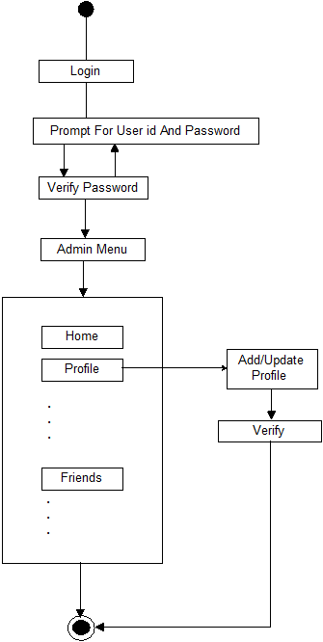

**Screenshots**

**index.php**

**sign page-**

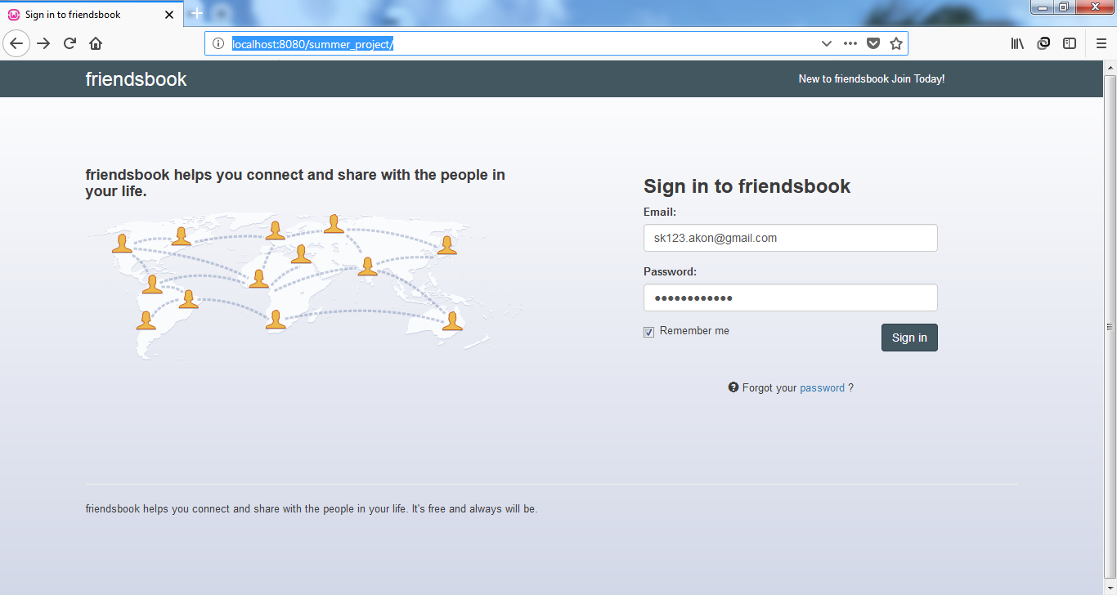

**registration.php**

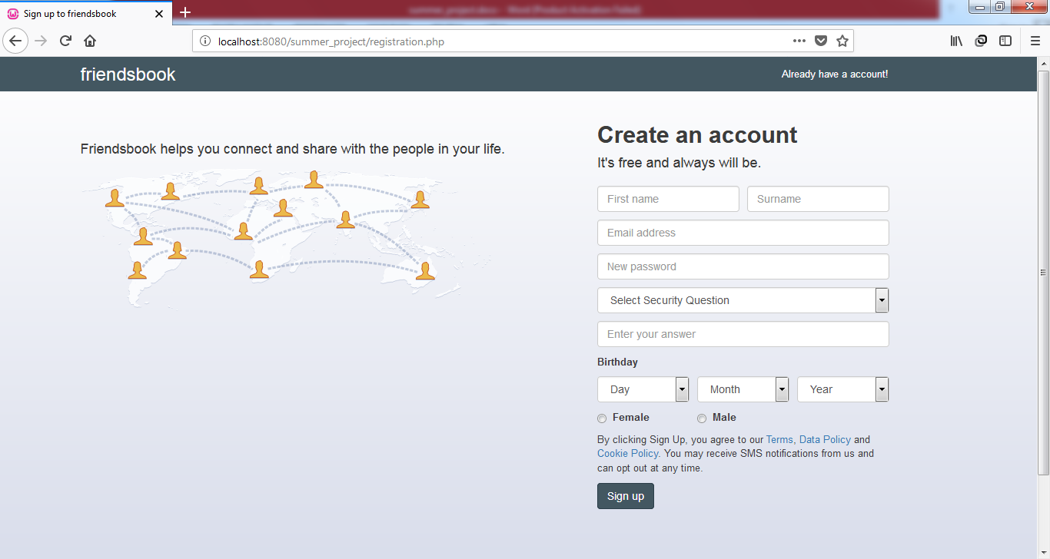

**forgot_password.php**

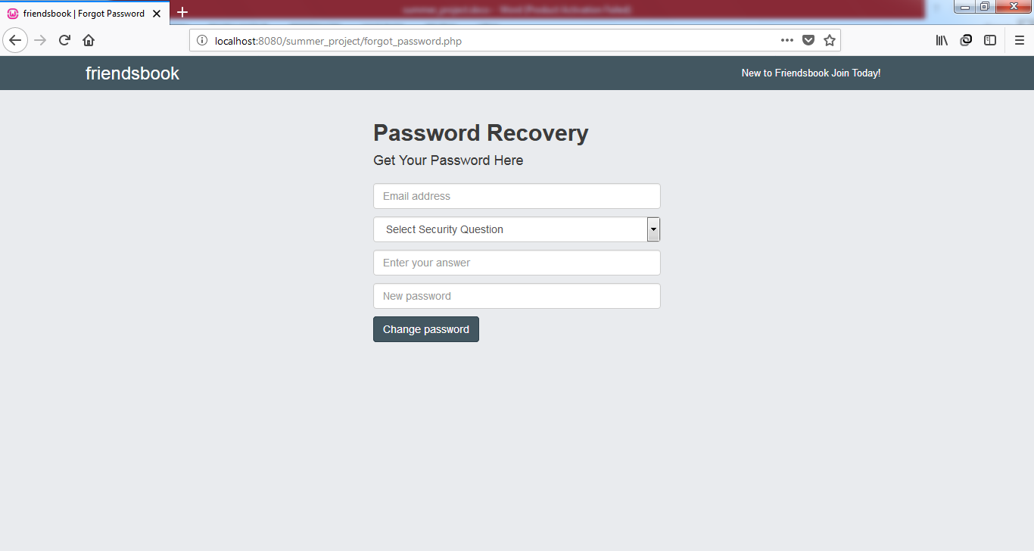

**home.php**

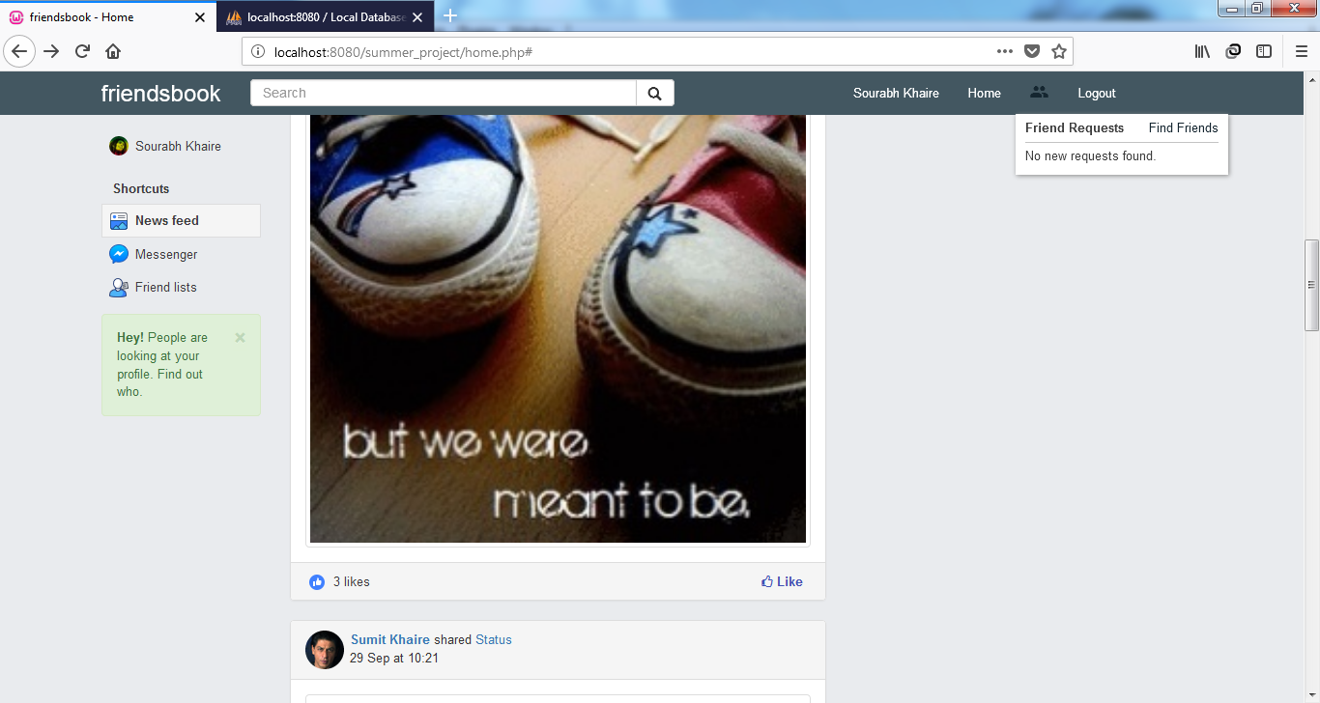

**Uploading post**

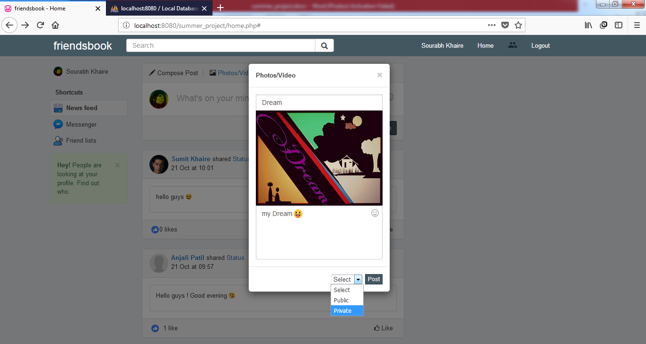

**profile.php**

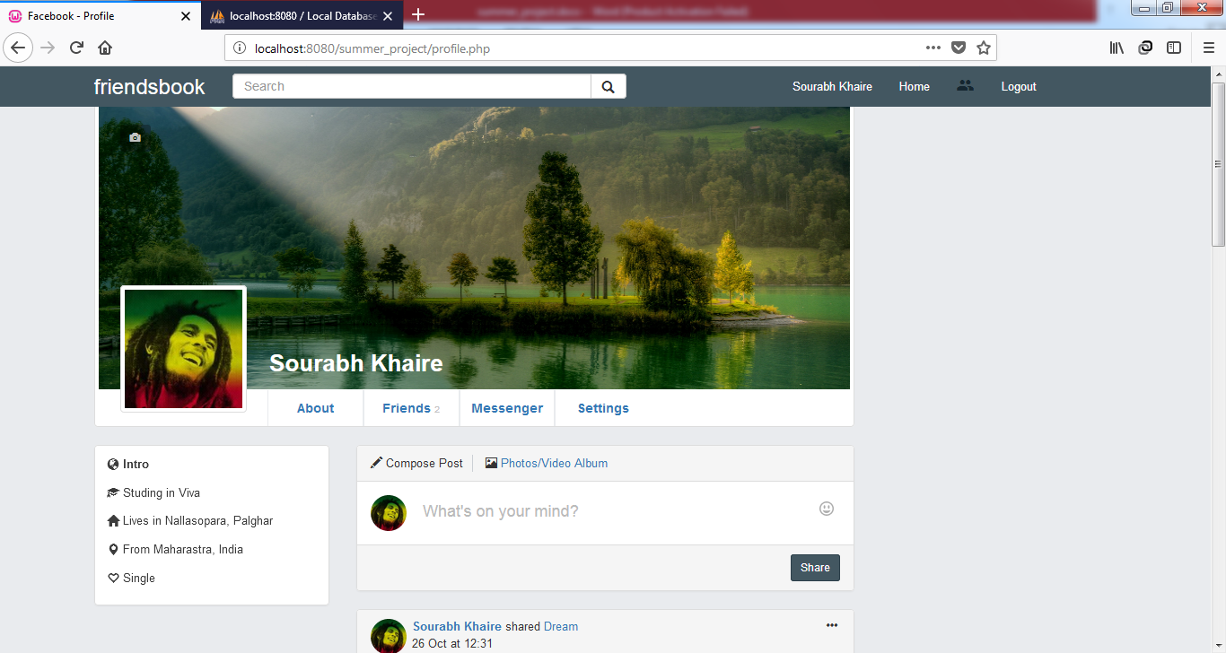

**About.php**

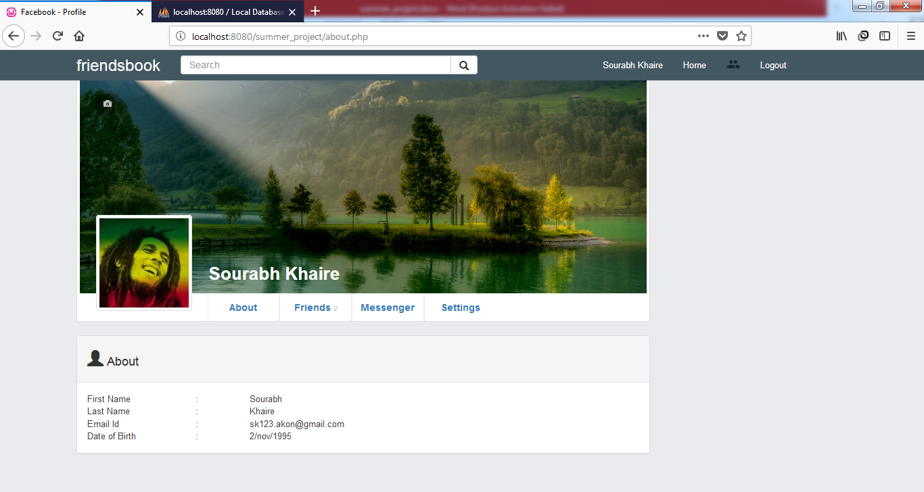

**Friend.php**

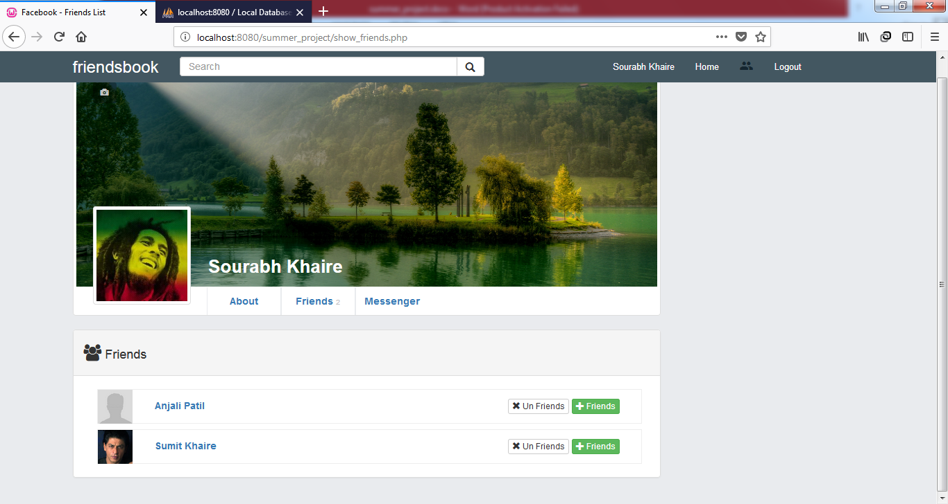

**Messenger.php**

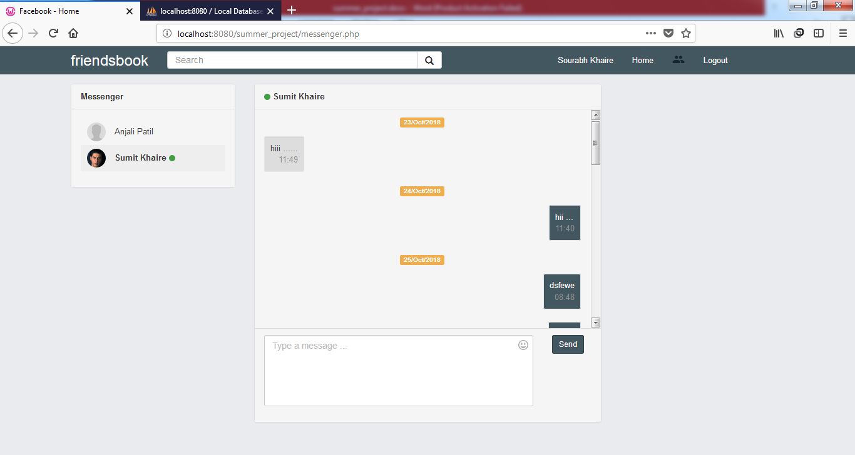

**Searching for new friends**

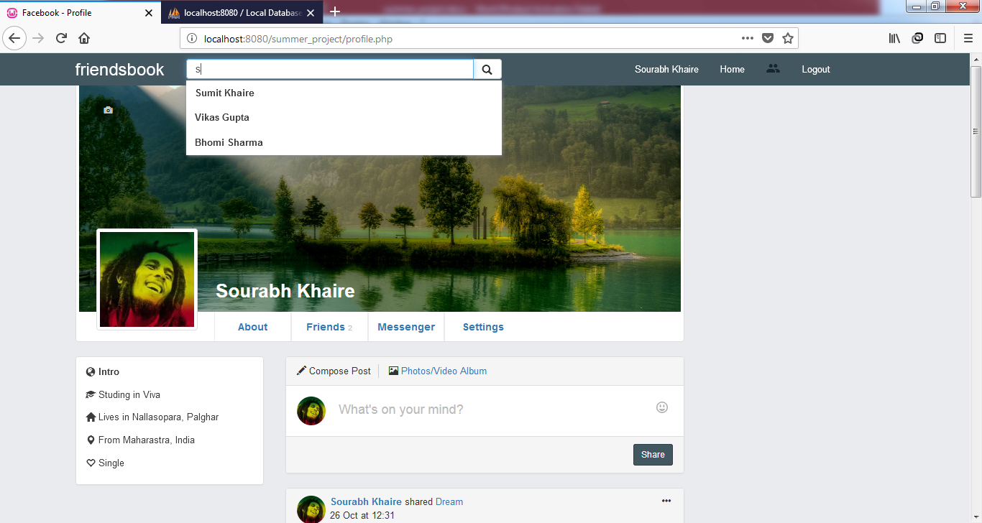

**search_list.php**

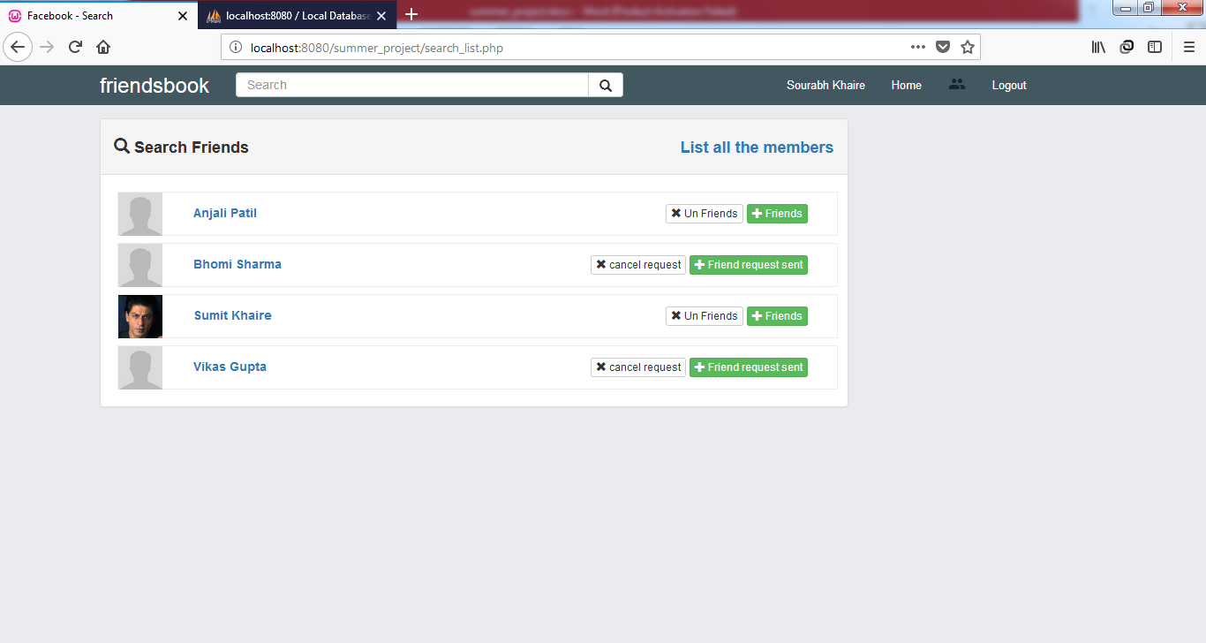

**others_profile.php**

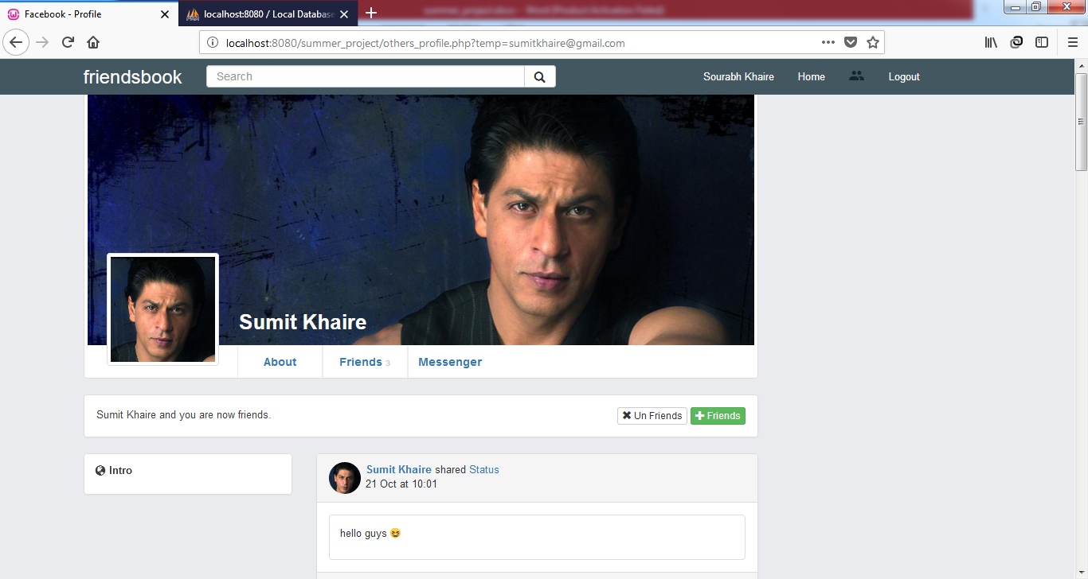

**Friend request notification**

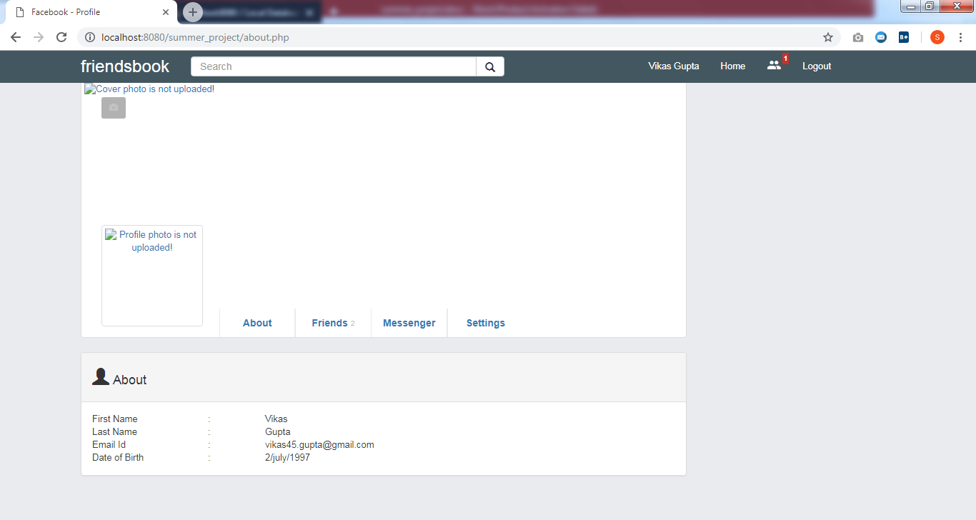

**settings.php**

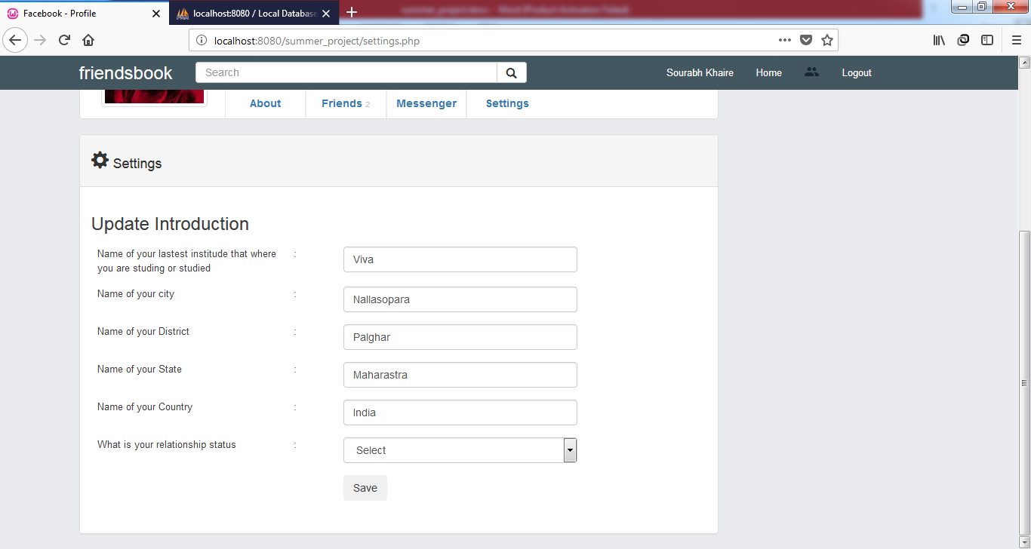

**Database**

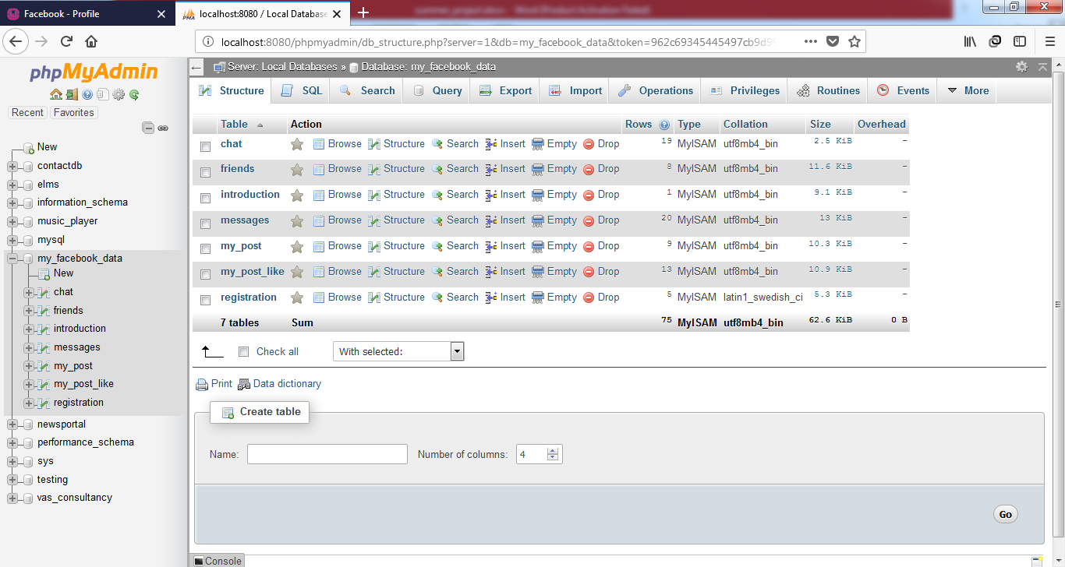

**Registration**

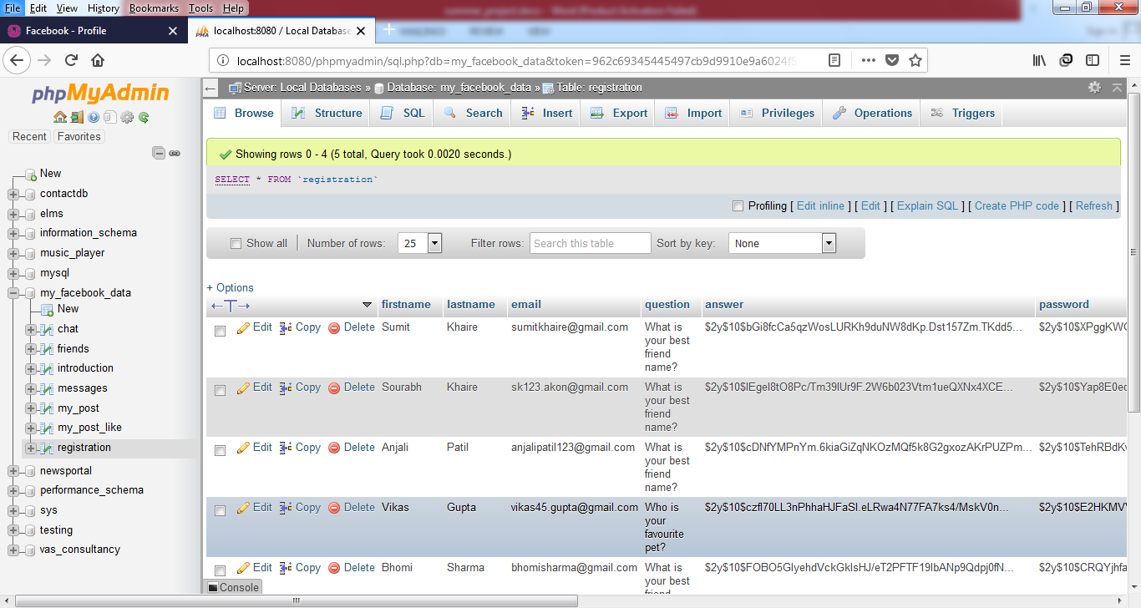

**Limitations**

* If Internet connection is slow it becomes difficult to fetch data from the database and execute the query.
* Server Problems.
* User cannot upload Link such as YOUTUBE videos or other website.

**Further Enhancement:**

Now, when such social networking site is easily approachable to the user via website, it is easy and convenient for them to be in touch with their colleagues. It gives further opportunity to the coming users to enhance the IT technologies.

* Update website according to user requirements
* Online Games and other application
* Different types of advertisement like Auction, Discounts, etc.
* Privacy of user information among other person on network
* User can create Group
* User can create and share Event information on profile
* Notification of each post and likes

**Conclusion**

From the above project I conclude that, Computerizes work is better than manual work. It also minimizes the risk of loss, maintains the speed and accuracy of the work and it also works smoothly and non-technical person can handle the software easily. It can be implemented in real life implementation.

**Bibliography**



**Websites Referred:**

* ***https://***[***www.1000projects.org***](http://www.1000projects.org)
* ***https://***[***www.w3schools.com***](http://www.w3schools.com)
* ***<https://stackoverflow.com>***
* ***https://www.wikipedia.org***
* ***https://www.tutorialspoint.com***